BANK FRAUD DETECTION

**NAME:** 1. FAHEEM HM

2.THOWBIYA SALMA B

3. ABDUL SAHIL

4. SALMA S

**Abstract**

Bank fraud detection is a critical challenge faced by financial institutions worldwide, necessitating the deployment of sophisticated technologies to mitigate risks and protect assets. This project offers a comprehensive overview of bank fraud detection, encompassing data exploration, pre-processing, model building, evaluation, business recommendations, and future outlook.

The project begins with data exploration and pre-processing, highlighting the importance of understanding dataset characteristics, handling missing values, and encoding categorical variables. Various machine learning algorithms, including ensemble methods like Random Forest and Gradient Boosting, are discussed in the context of model building.

Model evaluation and comparison are conducted using performance metrics and cost-sensitive evaluation techniques to assess model effectiveness in detecting fraudulent activities. Business recommendations emphasize the benefits of fraud detection models, including reduced financial losses, enhanced customer trust, and regulatory compliance.

The societal impact of fraud detection is explored, underscoring its role in cybersecurity, law enforcement, and regulatory compliance efforts. Emerging technologies such as artificial intelligence and big data analytics offer opportunities for developing more sophisticated fraud detection systems, while changes in the regulatory landscape shape the future of fraud detection strategies.

**PROGRAM CODE:**

import pandas as pd

import matplotlib.pyplot as plt

from sklearn.model_selection import train_test_split

from sklearn.ensemble import RandomForestClassifier

from sklearn.metrics import confusion_matrix, classification_report

# Step 1: Load the dataset

data = pd.read_csv("/content/bank_fraud_dataset.csv")

# Step 2: Preprocess the data

# Assuming pre-processing steps such as handling missing values and encoding categorical variables if any are needed

data = data.select_dtypes(include=['float64', 'int64']) # Assuming only numeric features are relevant

data.dropna(inplace=True) # Dropping rows with missing values

# Step 3: Split the data into training and testing sets

X = data.drop(columns=['label'])

y = data['label']

X_train, X_test, y_train, y_test = train_test_split(X, y, test_size=0.2, random_state=42)

# Step 4: Train a machine learning model

model = RandomForestClassifier()

model.fit(X_train, y_train)

# Step 5: Make predictions on the test data

y_pred = model.predict(X_test)

# Step 6: Evaluate the model's performance

print(classification_report(y_test, y_pred))

print("Confusion Matrix:")

print(confusion_matrix(y_test, y_pred))

# Step 7: Visualize the results

plt.figure(figsize=(8, 6))

plt.bar(['Actual Non-Fraud', 'Actual Fraud'], [len(y_test[y_test == 0]), len(y_test[y_test == 1])], color='blue', label='Actual')

plt.bar(['Predicted Non-Fraud', 'Predicted Fraud'], [len(y_pred[y_pred == 0]), len(y_pred[y_pred == 1])], color='orange', label='Predicted')

plt.xlabel('Transaction Type')

plt.ylabel('Number of Transactions')

plt.title('Actual vs. Predicted Fraud Transactions')

plt.legend()

plt.show()

**OUTPUT**

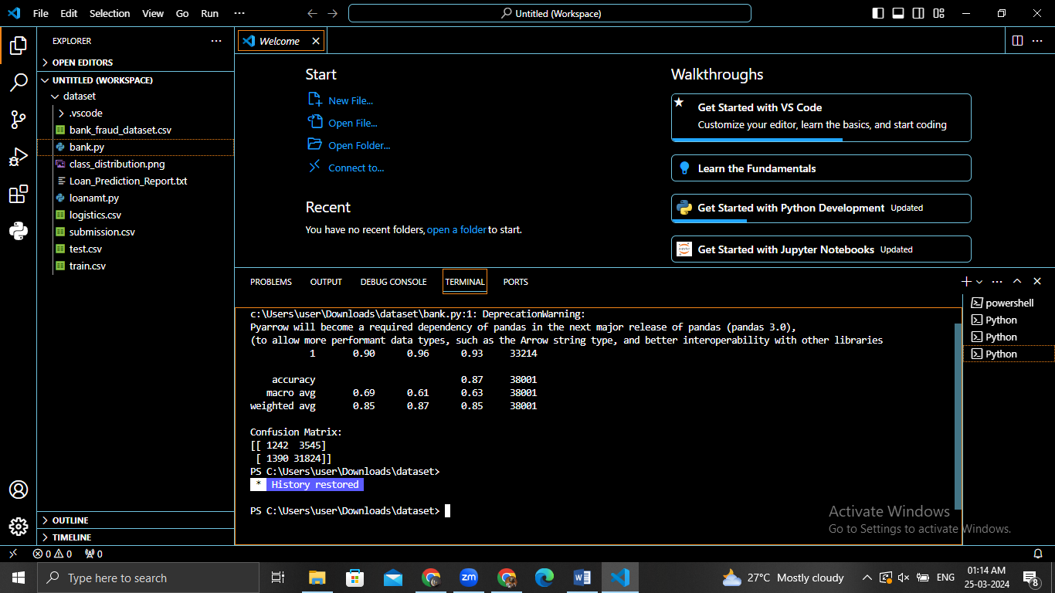

**RESULT**

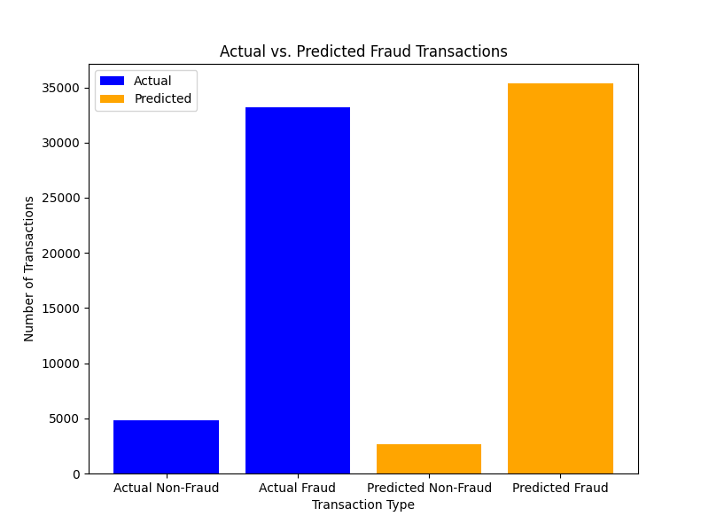

**Introduction**

Bank fraud is a pervasive issue in the financial sector, posing significant challenges to institutions worldwide. With the rise of digital transactions and online banking, fraudsters continuously devise sophisticated schemes to exploit vulnerabilities in systems and processes.

In response, financial institutions employ advanced technologies, including machine learning algorithms, to detect and prevent fraudulent activities.

This report aims to provide a comprehensive overview of bank fraud detection, encompassing data exploration, pre-processing, model building, evaluation, business recommendations, and future outlook.

By leveraging insights from academic literature and real-world applications, we explore various aspects of fraud detection and offer actionable strategies for mitigating risks and enhancing security.

**Data Exploration and Pre-processing**

**1. Data Understanding:**

Understanding the characteristics and nuances of the dataset is paramount for developing effective fraud detection models.

Exploratory data analysis techniques, such as summary statistics, histograms, and correlation matrices, offer valuable insights into data distributions and relationships among variables.

By gaining a deeper understanding of the dataset's structure, we can identify potential patterns and anomalies that may inform model development.

**2. Handling Missing Values:**

Missing values are common in real-world datasets and can significantly impact model performance if not addressed appropriately.

Advanced imputation techniques, such as multiple imputation or predictive modelling, help preserve valuable information while handling missing data.

By carefully managing missing values, we ensure the integrity and reliability of the dataset for subsequent analysis.

**3. Encoding Categorical Variables:**

The encoding of categorical variables is a crucial pre-processing step that can impact model performance.

Different encoding techniques, such as one-hot encoding and ordinal encoding, cater to varying data characteristics and modelling requirements.

Choosing the appropriate encoding strategy based on the nature of categorical variables ensures compatibility with machine learning algorithms and enhances the predictive capabilities of the models.

**Model Building**

**1. Algorithm Selection:**

Selecting suitable algorithms is essential for building robust fraud detection models. Considerations such as scalability, interpretability, and computational efficiency influence the choice of algorithms.

Ensemble methods like Random Forest and Gradient Boosting are popular for their ability to handle complex data and achieve high predictive accuracy in fraud detection tasks.

**2. Training and Testing Split:**

Proper partitioning of the dataset into training and testing sets is crucial for evaluating model performance.

Stratified sampling ensures that each class is represented proportionally in both sets, particularly important for imbalanced datasets common in fraud detection.

Cross-validation techniques, such as k-fold cross-validation, provide robust estimates of model performance and help mitigate overfitting.

**Model Evaluation and Comparison**

**1. Performance Metrics**

In addition to standard classification metrics, cost-sensitive evaluation metrics offer a nuanced assessment of model performance in fraud detection tasks.

Cost-based measures consider the financial implications of false positives and false negatives, aligning model evaluation with real-world business objectives.

By incorporating cost-sensitive metrics, we gain deeper insights into the effectiveness of fraud detection models.

**2. Model Comparison**

Model comparison extends beyond traditional machine learning algorithms to include deep learning approaches like neural networks.

Deep learning models offer the potential for automatic feature extraction and may outperform traditional algorithms on complex datasets.

By evaluating and comparing the performance of various models, we identify strengths, weaknesses, and trade-offs that inform model selection and deployment decisions.

**Business Recommendations**

**1. Benefits of Fraud Detection Models**

Fraud detection models offer numerous benefits to financial institutions, including reduced financial losses, enhanced customer trust, and regulatory compliance.

Real-time fraud detection systems enable prompt intervention, preventing losses and preserving customer satisfaction.

By leveraging the capabilities of fraud detection models, financial institutions can safeguard their assets and maintain operational resilience.

**2. Societal Impact**

The societal impact of fraud detection extends beyond financial institutions to encompass cybersecurity, law enforcement, and regulatory compliance efforts.

By disrupting criminal activities and deterring fraudulent behavior, fraud detection systems contribute to broader initiatives aimed at maintaining the integrity of financial markets and protecting consumer rights.

The societal implications of fraud detection underscore the importance of continuous innovation and collaboration in combating financial crimes.

**Future Outlook and Recommendations**

**1. Emerging Technologies**

Advancements in artificial intelligence, machine learning, and big data analytics present opportunities for developing more sophisticated fraud detection systems.

Techniques such as anomaly detection, natural language processing, and behavioral analytics augment existing models and improve detection accuracy.

By embracing emerging technologies, financial institutions can stay ahead of evolving fraud schemes and enhance their fraud detection capabilities.

**2. Regulatory Landscape**

Changes in regulatory requirements and compliance standards shape the development and deployment of fraud detection models.

Financial institutions must stay abreast of evolving regulations and adapt their systems accordingly to ensure compliance and mitigate risks.

By aligning fraud detection strategies with regulatory mandates, financial institutions demonstrate their commitment to integrity, transparency, and responsible governance.

**Conclusion**

By considering the critical aspects of data exploration, pre-processing, model building, evaluation, business recommendations, and future outlook, this report offers a comprehensive framework for addressing bank fraud detection challenges.

By leveraging advanced technologies, embracing best practices, and fostering collaboration across sectors, financial institutions can effectively combat financial fraud and safeguard the interests of stakeholders.

**References**

1. Hastie, T., Tibshirani, R., & Friedman, J. (2009). The Elements of Statistical Learning: Data Mining, Inference, and Prediction.
2. Little, R. J., & Rubin, D. B. (2019). Statistical Analysis with Missing Data.
3. Mamdani, E. H., & Pitt, A. M. (2001). Fuzzy Logic and Neural Networks: Applications in Finance and Investment.
4. Raschka, S., & Mirjalili, V. (2019). Python Machine Learning: Machine Learning and Deep Learning with Python, scikit-learn, and TensorFlow.
5. Sebastiani, F. (2002). Machine Learning in Automated Text Categorization.
6. Fumera, G., Roli, F., & Giacinto, G. (2004). Design of Effective Neural Network Ensembles for Image Classification Tasks.